Implementation Steps:

Installing the new namespace

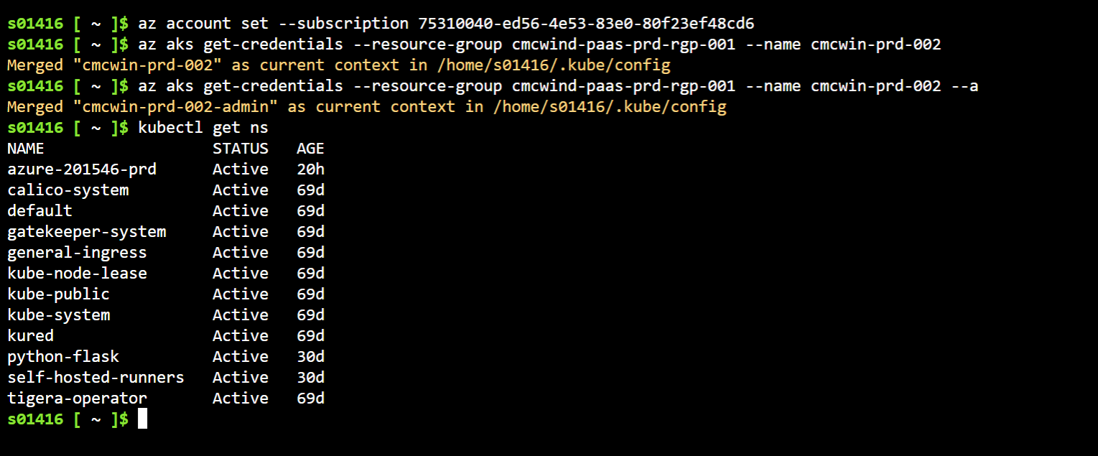

Deployment of Agents:

